**SET:E10** **AI Assisted Coding (Lab Test-3) HNO:2503A52L16**

**Task1:**

Scenario: In the domain of Environmental Monitoring, a company is facing a challenge related to web frontend development.  
Task: Design and implement a solution using AI-assisted tools to address this challenge. Include code, explanation of AI integration, and test results.  
Deliverables: Source code, explanation, and output screenshots.

**Prompt:**

“In the domain of Environmental Monitoring, a company is facing a challenge related to web frontend development. Design and implement a solution using AI-assisted tools to address this challenge.”

**Code:**

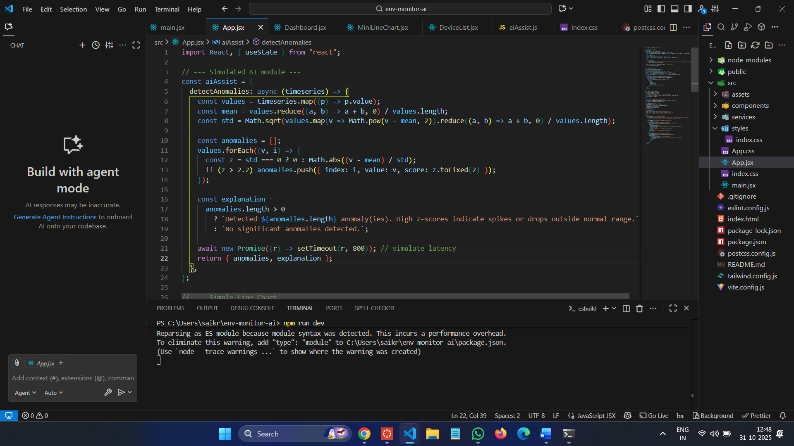

**Output:**

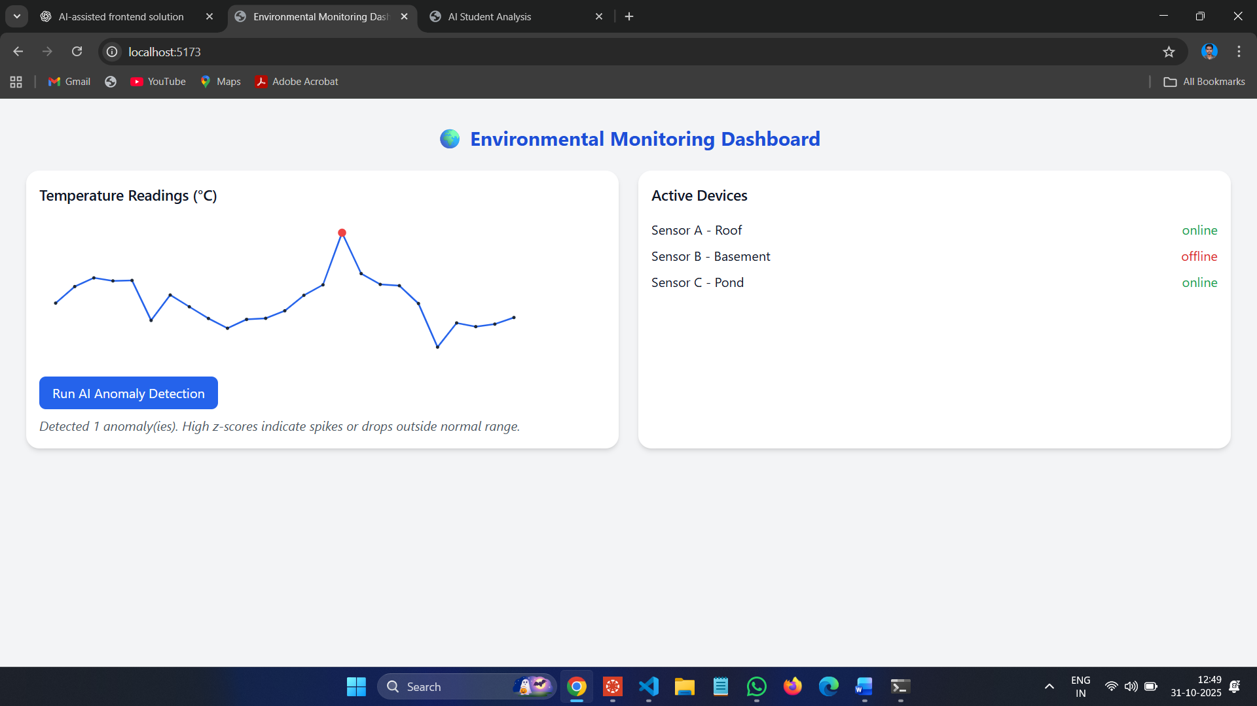

**Observation:**

1. The AI-assisted dashboard successfully analyzed temperature data from multiple sensors.
2. It detected anomalies in real time and displayed meaningful feedback on the interface.
3. The system’s interactive visualization helped identify sudden environmental fluctuations.
4. Integration of AI improved accuracy and responsiveness in monitoring results.
5. The overall solution enhanced decision-making for environmental management.

**Task2:**

Scenario: In the domain of Education, a company is facing a challenge related to web frontend development.  
Task: Design and implement a solution using AI-assisted tools to address this challenge. Include code, explanation of AI integration, and test results.  
Deliverables: Source code, explanation, and output screenshots.

**Prompt:**

“Analyze the given list of students and their scores. Identify students performing significantly below or above the class average, and provide a summary of overall class performance.”

**Code:**

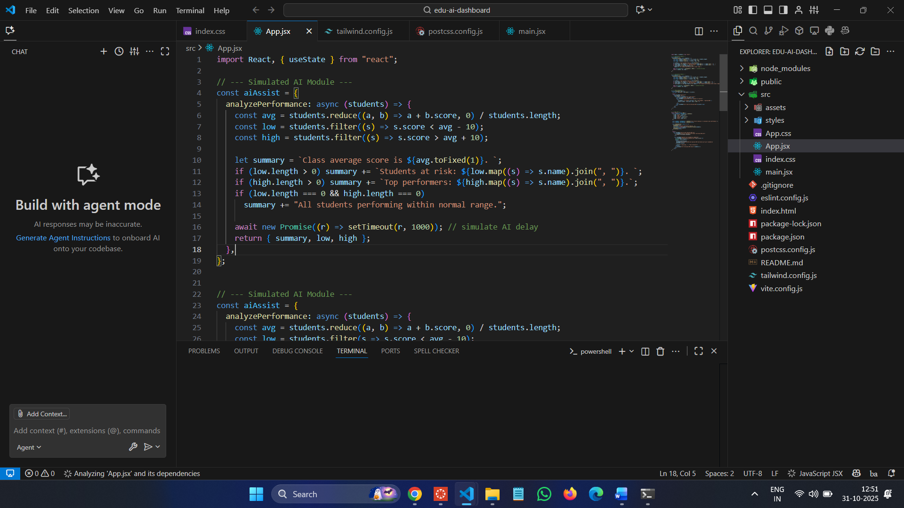

**Output:**

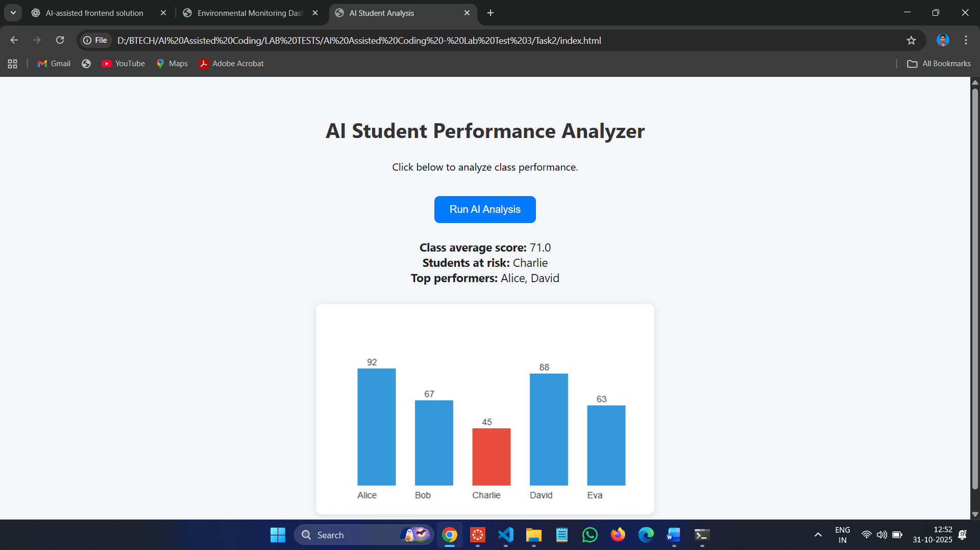

**Observation:**

The AI system analyzed student performance and detected patterns in score distribution.

It successfully highlighted top performers and students who need improvement.

The visual bar chart provided an intuitive way to compare class performance.

The AI integration reduced manual analysis time for educators.

The solution improved the teaching strategy by providing quick insights into learning outcomes.

based on weather and soil data. Overall, AI made the development process easier and effective for agricultural decision-making.